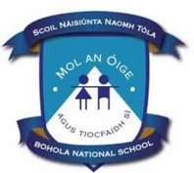

Bohola National School 19914F
ANNUAL ADMISSION NOTICE
in respect of admissions to the 2026/2027 school year

Admission Policy and Application Form

A copy of the school’s Admission Policy and the Application Form for Admission for the
2026/202 7 school year is available as follows: –

To download at: https://www.boholans.ie

On request: By emailing boholaschool@gmail.com or writing to:
The Principal,
Bohola N.S.
Bohola,
Claremorris, Co. Mayo F12PR53

Application and Decision Dates for admission to the 2026/2027 school year
The following are the dates applicable for admission to Junior Infants:

The school will commence accepting applications for admission on | 26/01/2026
The school shall cease accepting applications for admission on | 27/02/2026
The date by which applicants will be notified of the decision on their application is | 30/04/2026
The period within which applicants must confirm acceptance of an offer of admission is* | 14/05/2026

*Failure to accept an offer within the prescribed period above may result in the offer being withdrawn.
Note: the school will consider and issue decisions on late applications in accordance with the school’s Admission Policy.

